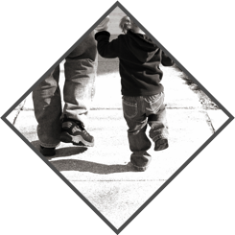

**PSS TM22-XXX-01**

**SIDEWALK TRIP HAZARD REMOVAL SURVEY AND PROPOSAL**

**Presented to: Name, Title**

**Submitted by:** Tamar Mitchell, Business Development Manager

(800) 734-8891 ext. 329 M: (540) 229-8470 | [t.mitchell@precisionsafesidewalks.com](mailto:t.mitchell@precisionsafesidewalks.com)

January 25, 2023

© 2022 Precision Safe Sidewalks, LLC.

# **ENTITY**

**ESTIMATE:** This estimate has been prepared for:

**ENTITY – TRIP & FALL HAZARD REMOVAL**

**Insert name, Insert title**

Insert address

Insert phone| Insert email

**EXECUTIVE SUMMARY:**

Using the information provided by Insert name for the ENTITY, Precision Safe Sidewalks conducted a risk assessment in a project area to identify sidewalk hazards that create trip and fall liabilities. Our assessment, conducted using the specifications of the Americans with Disabilities Act (ADA), revealed tripHazardCount trip and fall hazards as shown in Table 1 below:

|  |  |  |  |
| --- | --- | --- | --- |
| **TABLE 1: MILEAGE** | | | |
| **LOCATION** | **Estimated Sidewalk Miles** | **Total Hazards** | **Ave Hazard Occurrence (Feet)** |
|  |  |  |  |
|  |  |  |  |
|  |  |  |  |
|  |  |  |  |
|  |  |  |  |
|  |  |  |  |
|  |  |  |  |
|  |  |  |  |
|  |  |  |  |
|  |  |  |  |
|  |  |  |  |
|  |  |  |  |
|  |  |  |  |
|  |  |  |  |
|  |  |  |  |
|  |  |  |  |
|  |  |  |  |
|  |  |  |  |
|  |  |  |  |
|  |  |  |  |
| **TOTAL** |  |  |  |
| **\*\*\* Average Hazard Occurrence = SQ66 Feet \*\*\*** | | | |

We observed that the sidewalk infrastructure in the assessed area is in generally good structural condition and is an ideal application for our precision-concrete-cutting repair method. Precision Safe Sidewalks proposes to remove all **tripHazardCount** **identified sidewalk trip and fall hazards** **and restore curbLength identified linear feet of curb hazards at points of egress** in the assessed areas, meeting the customer’s requirements, for **totalHazardCost** (Sidewalks swCost + Curbs curbCost). We have also provided the ability to select a subset of the hazards for repair by CLASS and AREA.

Should you request all hazards be repaired, Precision Safe Sidewalks can complete the work in as few as **expNumDaysToRepair** workday with 1 technician. While the sidewalk restoration project is underway, we will:

* keep the sidewalks in service
* require no heavy equipment or traffic control
* remove all debris and recycle the concrete waste materials
* leave the area clean and trip and fall hazard-free.

There are, however, approximately **dnrSqft square feet** that will require demolition and replacement (D&R) that we cannot repair (Exhibit C).

**Estimated Savings Summary:**

We estimate our innovative, patented, precision-concrete-cutting method will save Entity more than **pssSavings** on this project over traditional D&R methods.

We would be happy to discuss any aspect of this proposal and look forward to working with Entity to enhance its sidewalk ADA compliance program, reduce liability for trip and fall incidents, and improve safety of public walkways.

At Entity's request, Precision Safe Sidewalks, LLC. will evaluate additional or alternate locations where our repair services can help stretch funds for sidewalk repairs.

**RISK ASSESSMENT HAZARD LOCATIONS**

**METHODOLOGY – PREPARING THIS ESTIMATE:**

1. A census was conducted of all hazards; the hazards were then grouped into three CLASSES and numberOfAreas AREAS:

**CLASSES SPECIFICATIONS**

MOST SEVERE: 1 inch to 2½ inches

SEVERE: ½ inch to 1 inch

LEAST SEVERE: ¼ inch to ½ inch – Not Surveyed (remove if surveyed)

1. An estimate of inch feet for each CLASS was prepared based on our experience database.
2. A fixed bid was prepared giving the flexibility to choose to repair hazards by CLASS, AREA or all hazards in the proposal.
3. This project is subject to progress billing.

**PRICING OPTION 1: REPAIR SELECTED HAZARDS BY CLASS or AREA**

|  |  |  |  |  |  |  |
| --- | --- | --- | --- | --- | --- | --- |
| **TABLE 2: SIDEWALK TRIP & FALL HAZARDS** | | | | | | |
| **AREA** | **LOCATION** |  | **LEAST SEVERE** | **SEVERE** | **MOST SEVERE** | **TOTAL** |
| **A** |  | Hazards |  |  |  |  |
| **Cost** |  |  |  |  |
| **B** |  | Hazards |  |  |  |  |
| **Cost** |  |  |  |  |
| **C** |  | Hazards |  |  |  |  |
| **Cost** |  |  |  |  |
| **D** |  | Hazards |  |  |  |  |
| **Cost** |  |  |  |  |
| **E** |  | Hazards |  |  |  |  |
| **Cost** |  |  |  |  |
| **F** |  | Hazards |  |  |  |  |
| **Cost** |  |  |  |  |
| **TOTAL ALL AREAS** | | Hazards |  |  |  |  |
| **Cost** |  |  |  |  |
|  | | | | | | |

*Note: Our company minimum to mobilize is $5,000*

You can choose any or all cells for repair in this option. For example, if you choose to repair all the MOST SEVERE and SEVERE hazards, the price is mLCost. If you wanted to repair all trip and fall hazards in AREA X, name of area, the price is $xxxx. The options to make sidewalk repairs at a slope of 1:10 or 1:12 are available for any pricing option.

There are also curb hazards at points of egress adjacent to the curbside sidewalk hazard portion of this assessment. The additional price to restore these curb hazards at points of egress is curbCost. Hazard example pictures are found in Exhibit A along with sample restoration pictures in Exhibit B.

|  |  |  |  |
| --- | --- | --- | --- |
| **TABLE 2.5: CURB HAZARDS** | | | |
| **AREA** | **LOCATION** | **LINEAR FEET** | **TOTAL** |
| **A** |  |  |  |
| **B** |  |  |  |
| **C** |  |  |  |
| **D** |  |  |  |
| **E** |  |  |  |
| **F** |  |  |  |
| **TOTAL** | |  |  |
|  | | | |

**PRICING OPTION 2: REPAIR ALL HAZARDS**

Precision Safe Sidewalks will remove **all identified sidewalk** and **curb hazards in the assessed area** from ¼” to 2½” for a **fixed price of** **totRepairCost** (Sidewalks swRepairCost + Curbs curbRepairCost).

**SCOPE OF WORK:**

The scope of work includes identifying, measuring, recording, marking, and repairing the sidewalk hazards noted in our census at a slope of 1:8 (ramps at 1:12), and removing approximately pssConcRem lbs. of concrete debris from the area. Typically, we recycle this debris.

**AVERAGE PRICE PER SQUARE FOOT: avgPrice**

There are totalSqft total square feet in the project area. Precision Safe Sidewalks’ average price per square foot for the total project is avgPrice compared to an estimate of dnrPrice per square foot for the Entity to demolish and replace it. Estimated D&R costs for Entity include:

* Cost of concrete – $100 per cubic yard
* Underground scanning for lines, wires, utilities
* Tree and root removal
* Hydro excavation to remove soil with pressurized water near underground utilities
* Labor and Break up to remove existing concrete
* Labor to Pour, Form, Level, Finish, Float & Cut control joints.
* Fuel for multiple site visits to repair or break-up, remove, pour, remove forms, and restore adjacent items
* Equipment such as a backhoe, vehicle to transport backhoe, utility vehicle, and dump truck to remove debris
* Miscellaneous materials to prepare concrete
* Landscape repair

|  |
| --- |
| **TABLE 3: COST PER SQUARE FOOT** |
|  |
|  |

**ESTIMATED SAVINGS: allPssSavings**

If all the panels were demolished and replaced at a replacement cost of dnrPrice per square foot, we estimate Entity will save more than allPssSavings by using Precision Safe Sidewalks.

**REPAIR SCHEDULE & DURATION: dtcLow** – **dtcHigh Days**

When scheduled, we estimate the repairs for all hazards on the property will require dtcLow to dtcHigh workdays with the note that wet weather days will delay our operations. We will remove small sections (10' to 15') of sidewalk from service for periods that range from 3 minutes to 45 minutes and will control all traffic around these areas while they are being repaired. No assistance will be required from Entity, although we welcome site visits, evaluations, or inspections at your convenience at any time.

**REPAIR SPECIFICATIONS**:

1. Three measurements will be taken of every hazard:

* Height1 – the highest point of the hazard
* Height2 – the lowest point of the hazard
* Length
* Full Address Location

2. Hazards will be removed from the full length of the panel (full edge-to-edge repair);

3. Sidewalks will be repaired at a slope of 1:8

4. Handicap ramps or special areas will be repaired at a slope of 1:12. Debris from repaired areas will be

collected and removed

5. A dust abatement system will be used during all repair operations

6. The repaired area will be smooth and uniform with a coefficient of friction exceeding OSHA requirements

for public walkways

7. A detailed, auditable invoice will be presented for every repair.

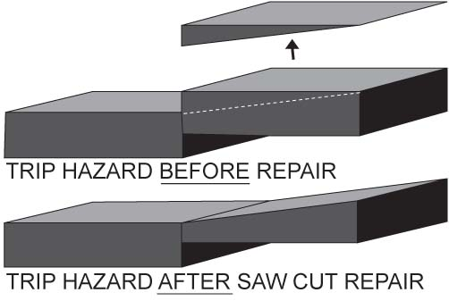

**WARRANTY:**

Precision Safe Sidewalks, LLC. guarantees its work:

1. All trip and fall hazard repairs will have a zero point of differential in height with the adjacent panel.
2. Repairs will affect only the panel causing the hazard; adjacent panels or immovable objects will be unaffected.
3. The slope of all repairs will be at your specification. For this estimate, we have assumed a repair slope of 1:8.

4. The repaired surface will exceed OSHA requirements for friction on public walkways.

**SAFETY:**

Precision Safe Sidewalks, LLC. has a flawless safety record; we use OSHA approved equipment, certify all employees who work directly in trip and fall hazard repair, and have outstanding safety practices for both employees and the public who may be using the walkways we are repairing. We have worked in dense urban, high pedestrian traffic areas, universities as well as residential neighborhoods and historic districts to complete projects without incident. Our clients often receive unsolicited compliments for the work we have performed for them.

**INSURANCE and INCORPORATION:**

Precision Safe Sidewalks, LLC. is a corporation registered in the state of South Carolina with a Certificate of Authority to operate in North Carolina, Virginia, West Virginia, Pennsylvania, New York and the District of Columbia. We serve the entire states of North Carolina, Virginia, West Virginia and the District of Columbia. Proof of liability, workers compensation, and auto insurance will be provided as requested.

**SOLE SOURCE:**

Due to the nature of our business, and in lieu of the ability to receive competitive bids, frequently we have been asked to provide a letter stating that our technology relies upon patents that have been issued by the US Patent and Trademark office. These patents enable us to provide the best available trip and fall hazard removal service to our clients.

Within the states of North Carolina, Virginia, West Virginia, Pennsylvania, New York and the District of Columbia, Precision Safe Sidewalks, LLC. is the only company authorized to use the patented equipment and method for removing sidewalk trip and fall hazards as described by the following patent numbers:

U.S. Pat. No. 6,827,074

U.S. Pat. No. 7,000,606

U.S. Pat. No. 7,143,760

U.S. Pat. No. 6,896,604

U.S. Pat. No. 7,201,644

U.S. Pat. No. 7,402,095

U.S. Pat. No. 9,759,559

Generally, these patents apply to the cutting equipment, cutting method, and dust abatement system used by Precision Safe Sidewalks, LLC. A sole source letter is available upon request.

**US GREEN BUILDING COUNCIL MEMBER**

The U.S. Green Building Council (USGBC) is a 501(c)(3)

nonprofit membership organization with a vision of a

sustainable built environment within a generation. Its

membership includes corporations, builders, universities,

government agencies, and other nonprofit organizations.

USGBC is dedicated to expanding green building practices

and education and its LEED® (Leadership in Energy and

Environmental Design) Green Building Rating System™.

As a member of the Green Building Council, we track savings from the use of our service, which is a green building practice. For this project, we estimate savings will include:



**GREEN PARAMETERS:**

**Estimated Natural Resources Saved:**

* + between tonsLow and tonsHightons of waste concrete from removal and landfills

(totCubFt cubic feet of concrete at an average weight of 132 to 140 lbs. per cubic foot)

* + approximately same amount of materials and resources to replace the concrete that was removed

**Estimated Fossil Fuels Saved: totFuelSaved gallons**

* + hauling equipment to and from the site to remove sidewalks
  + operating backhoe equipment to break up and remove concrete
  + round trip transportation of tonsLow to tonsHigh tons of debris to the landfill
  + round trip transportation of new materials to replace the removed sidewalks

**Estimated Greenhouse Gas Emissions Avoided**: totCO2 **Metric Tons C0₂**

Our clients often wonder what reducing carbon dioxide (C0₂) emissions from repairing sidewalks means in everyday terms – instead of demolishing and replacing them. We have taken the parameters from your project and used the Greenhouse Gas Equivalencies Calculator (provided by the US Environmental Protection Agency) to help understand just that. For this project, an estimated totCO2 *Metric Tons of C0₂ – Carbon Dioxide orC0₂ equivalent gases will not be produced*: This is the result of repairing the trip and fall hazards on sidewalks versus removing the sidewalk panels and sending them to the landfill.

**PICTURES & SPECIAL CASES:**

Pictures of MOST SEVERE and SEVERE hazard examples and Special Cases in the project area are included in Exhibit A.

Some sidewalk panels were cracked but serviceable – if the hazard around the crack was repaired; if a panel had 2 or more cracks, no repair work was estimated. Generally, if a panel had one or two cracks and was serviceable, repairs were estimated and included in the totals above. These numbers are small and not significant.

There are approximately dnrSqft square feet of sidewalk where D&R will be necessary that we cannot repair. This information is available in Exhibit C.

There are curb trip and fall hazards created by sunken sidewalk panels at points of egress. Precision Safe Sidewalks, LLC. can repair these curbs using its precision concrete cutting process. Completed curb repairs will be finished with a beveled edge similar to examples included in Exhibit B.

**UNREPAIRABLE HAZARDS and FINAL INSPECTION:**

A small percentage of trip and fall hazards cannot be repaired using our process. At the completion of work in this project, Precision Safe Sidewalks' inspectors will conduct a final assessment of the project area to compile a census of the locations and size of the areas that will need D&R. The contents of this table include:

* Address
* GPS Location Coordinates
* Square Footage

**CONFIDENTIALITY:**

This copyrighted material is presented by Precision Safe Sidewalks, LLC. to Entity for the purpose of evaluating an offer to provide trip and fall hazard removal services. These literary, graphic, and pictorial works may not be reproduced or retransmitted in any form and the information presented in this proposal may not be disseminated without express written consent.

**PROJECT INITIATION:**

When advised of acceptance of this proposal, Precision Safe Sidewalks will assign an Operations Manager for the project who will conduct a kick-off meeting with the project manager assigned by Entity. During this meeting, we will discuss:

* Project Strategy and starting location
* Project Schedule and work days
* Special scheduling requests
* Reporting on progress
* General specifications for repairs
* Contact information
* Additional Entity requirements

**EXHIBIT A**

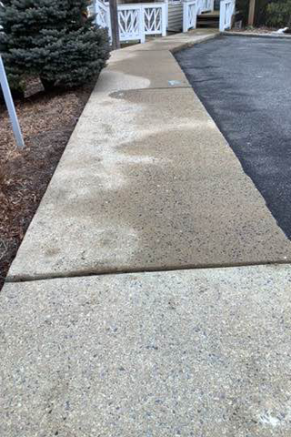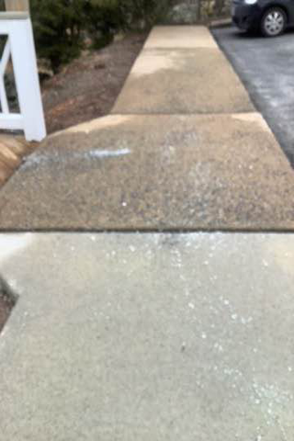

**SEVERE**

**TRIP AND FALL HAZARD**

Repairable using Precision

Concrete Cutting Process

**SEVERE**

**TRIP AND FALL HAZARD**

Repairable using Precision

Concrete Cutting Process



**SEVERE**

**TRIP AND FALL HAZARD**

Repairable using Precision

Concrete Cutting Process

**SEVERE**

**TRIP AND FALL HAZARD**

Repairable using Precision

Concrete Cutting Process



**SEVERE**

**TRIP AND FALL HAZARD**

Repairable using Precision

Concrete Cutting Process

**SEVERE**

**TRIP AND FALL HAZARD**

Repairable using Precision

Concrete Cutting Process



**SEVERE**

**TRIP AND FALL HAZARD**

Repairable using Precision

Concrete Cutting Process

**SEVERE**

**TRIP AND FALL HAZARD**

Repairable using Precision

Concrete Cutting Process

**EXHIBIT B**

**Sidewalk Trip and Fall Hazard Repair Example**

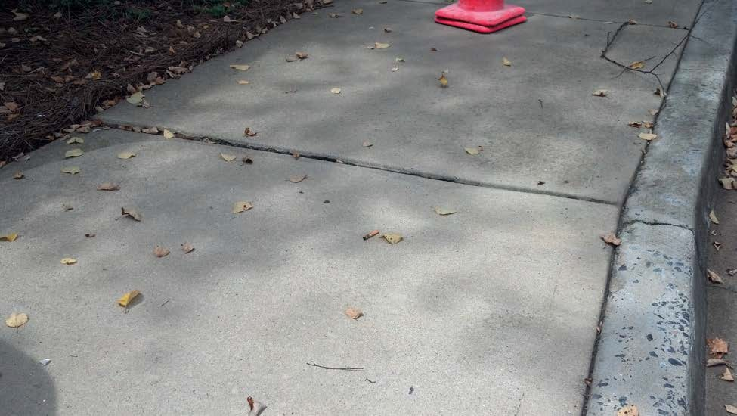

**BEFORE**

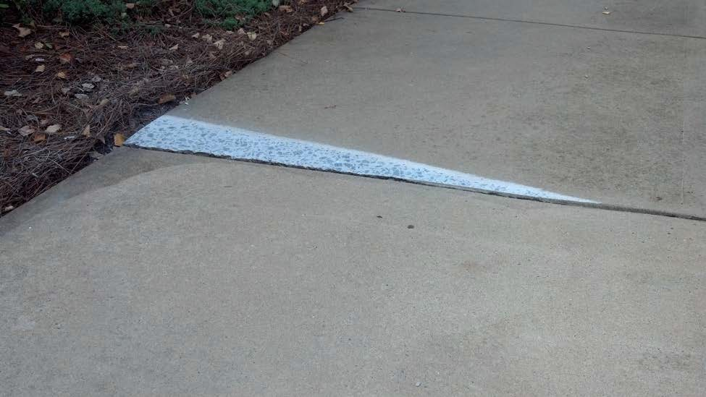

**AFTER**

**Curb Repair Examples**

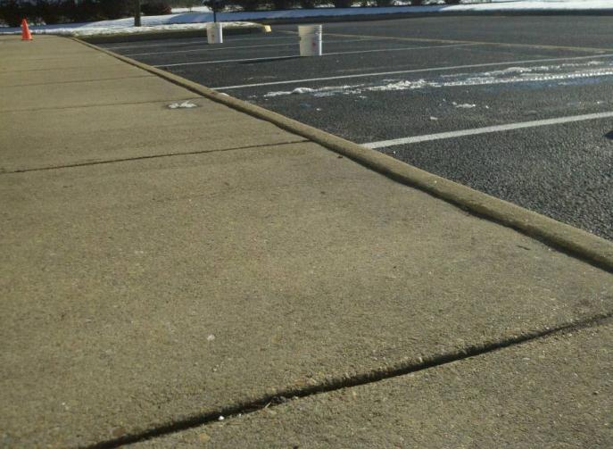

**BEFORE**

1+ Inch Curb Trip Hazard

Created by a Sunken Panel

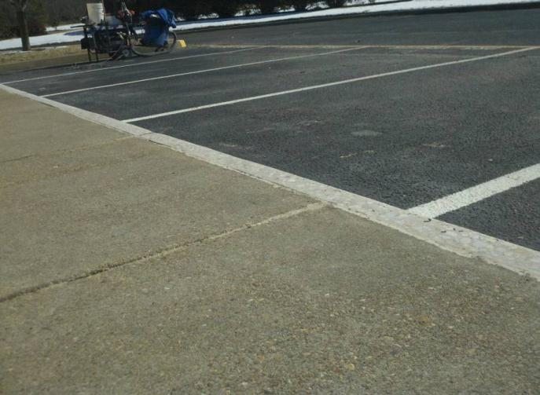

**AFTER**

Curb Trip Hazard Removed

Now Level with Sidewalk Panel

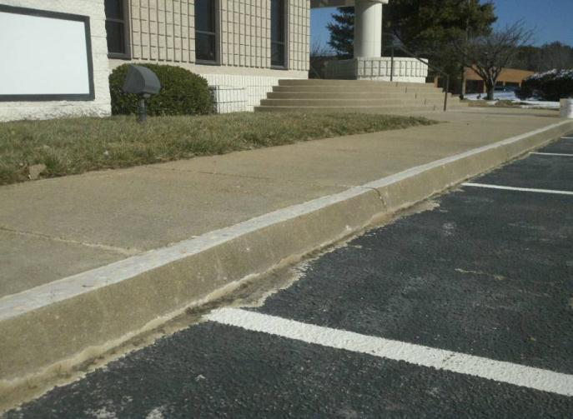

**AFTER**

Curb Trip Hazard Removed

Curbs Level with Sidewalk Panel

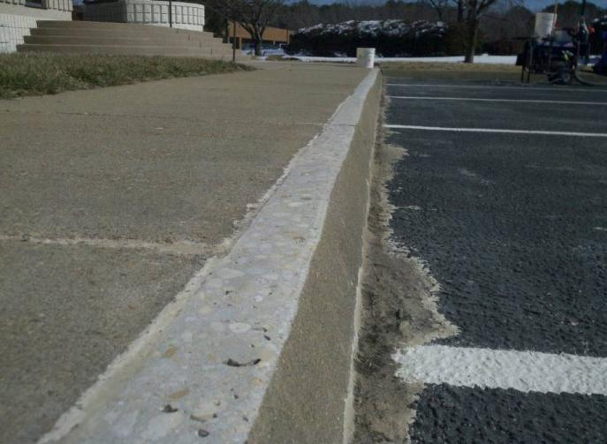

**AFTER**

Curb Trip Hazard Removed

Beveled Edge Restored

**EXHIBIT C**

|  |  |  |
| --- | --- | --- |
| **TABLE 4: DEMOLISH & REPLACEMENT PANELS (D&R)** | | |
| **Area** | **Location** | **Square Feet** |
| A |  |  |
| B |  |  |
| C |  |  |
| D |  |  |
| E |  |  |
| F |  |  |
| **Total** | |  |

**D&R EXAMPLES**



**EXHIBIT D**

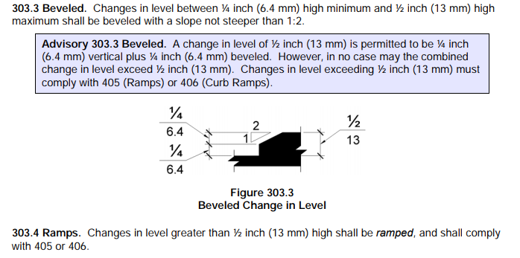

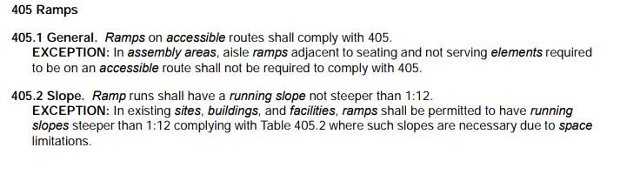

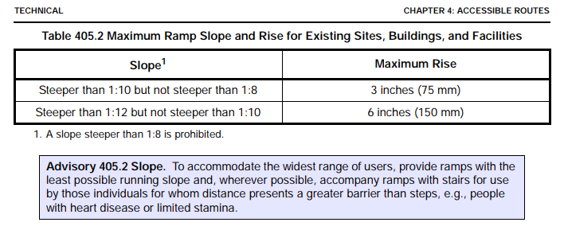

**NOTES**

1. PSS priced this proposal based on the customer’s approved repair specifications. The ADA’s guidance on sidewalk repair is provided in Exhibit D for the customer’s review (see sections 303 and 405). Approval of this project by any method is approval of the specifications/slopes priced in the proposal.

2. PSS repairs only those uneven sidewalks specifically approved by you, our customer, and therefore makes no guarantee that the property is free of uneven sidewalk hazards or other trip hazards. Once on site, PSS may not complete a repair(s) because; 1. a hazard’s actual measurement at the time of repair exceeds approved customer specifications, and/or 2. in the crew leader’s judgment, our repair attempt would cause further damage to the concrete slab or be insufficient to satisfactorily remove the existing hazard and/or mitigate its potential liability. Such excluded hazards, if any, will be left “as found” and will require customer’s alternative remedy. After the project is completed, new trip hazards may occur or reoccur due to tree roots, water, settling, and other natural and man-made causes outside of PSS’ control. Upon completion of the project, PSS is not liable for any related claims, losses, or damages. PSS will not be held responsible for cracks or defects in poured concrete that may exist due to materials or methods used by original installer.

3. PSS does not and shall not discriminate on the basis of race, color, religion (creed), gender, gender expression, age, national origin (ancestry), disability, marital status, sexual orientation, or military status, in any of its activities or operations. These activities include, but are not limited to, hiring and firing of staff, selection of volunteers and vendors, and provision of services. We are committed to providing an inclusive and welcoming environment for all members of our staff, clients, volunteers, subcontractors, vendors, and clients.

4. PSS is an equal opportunity employer. We will not discriminate and will take affirmative action measures to ensure against discrimination in employment, recruitment, advertisements for employment, compensation, termination, upgrading, promotions, and other conditions of employment against any employee or job applicant on the bases of race, color, gender, national origin, age, religion, creed, disability, veteran's status, sexual orientation, gender identity or gender expression.

5. PSS is committed to providing a safe environment for all its employees free from discrimination on any ground and from harassment at work including sexual harassment. PSS will treat all incidents seriously and promptly investigate all allegations of sexual harassment. Any person found to have sexually harassed another will face disciplinary action, up to and including dismissal from employment. All complaints of sexual harassment will be taken seriously and treated with respect and in confidence. No one will be victimized for making such a complaint.

6. Sexual harassment is unwelcome conduct of a sexual nature which makes a person feel offended, humiliated and/or intimidated. It includes situations where a person is asked to engage in sexual activity as a condition of that person’s employment, as well as situations which create an environment which is hostile, intimidating or humiliating for the recipient. Sexual harassment can involve one or more incidents and actions constituting harassment may be physical, verbal and non-verbal.

7. While we endeavor to perform our services in a professional, thorough, and workmanlike manner, we work with hundreds or thousands of hazards on each job and therefore cannot make any guarantees or warranties regarding the completeness of hazard removal. Should you identify any hazards that were missed, whether within the specified scope of this project or not, please contact us and we will work with you to address them.

8. In accepting any portion of this proposal, if you certify a job is not subject to prevailing wage, and it is later determined to be a prevailing wage job, there will be a 30% upcharge or the calculated additional cost of the wages, whichever is greater.

**ACCEPTANCE OF PROPOSAL**

FAX TO: (800) 734-8891

Or EMAIL TO: [BDEmail](mailto:t.mitchell@precisionsafesidewalks.com)

**Repair of trip and fall hazards in areas identified in PROPOSAL NUMBER: PSS TM22-XXX-01**

**SCOPE of PROJECT**:

**OPTION/COST:**

Date:

**P. O. NUMBER**:

Name:

**APPROVED BY**:

Signature:

Title:

Email:

Phone:

**NOTES:**

Upon receipt of this signed acceptance, Precision Safe Sidewalks, LLC. will schedule the requested repairs. Every effort will be made to accommodate the Requested Start Date. Approved projects are subject to progress billing.

Upon receipt of this signed acceptance, Precision Safe Sidewalks, LLC. will schedule the requested repairs. Every effort will be made to accommodate the Requested Start Date. Approved projects are subject to progress billing.

Upon receipt of this signed acceptance, Precision Safe Sidewalks, LLC. will schedule the requested repairs. Every effort will be made to accommodate the Requested Start Date. Approved projects are subject to progress billing.

Upon receipt of this signed acceptance, Precision Safe Sidewalks, LLC. will schedule the requested repairs. Every effort will be made to accommodate the Requested Start Date. Approved projects are subject to progress billing.

Upon receipt of this signed acceptance, Precision Safe Sidewalks, LLC. will schedule the requested repairs. Every effort will be made to accommodate the Requested Start Date. Approved projects are subject to progress billing.

Upon receipt of this signed acceptance, Precision Safe Sidewalks, LLC. will schedule the requested repairs. Every effort will be made to accommodate the Requested Start Date. Approved projects are subject to progress billing.